TITLE (concise and compact, consists of up to a maximum of 10 words without using abbreviations)

Author A¹⁾, Author B^{2)*}, etc.

¹⁾ Author A’s Affiliation, ²⁾ Author B’s Affiliation, dst. (or)
^{1, 2)} Author A & B’s Affiliation (If the authors’ affiliation is the same)

E-mail: author A ¹⁾, author B ^{2)*}
*correspondence author

ABSTRACT
ARTICLE INFO

COPY PASTE the title of the article here

Submitted:
…………….. (editor)
Revised:
…………….. (editor)
Accepted:
…………….. (editor)

Write an abstract using English and consists of up to a maximum of 200 words in the abstract without including any statistical figures. Abstract includes at least the phenomena underlying this research, purposes, methods, results and conclusions of the research carried out concisely.

Keywords: …, …., … (at least 3 relevant keywords)

INTRODUCTION

The text of manuscript use a justify style, the font face is Times New Roman (12), Space 1 (Before : 0pt After : 6pt).
Contains background related to research both in general and specifically, descriptions of problems that occur that can be understood by readers, research phenomena, theories related to research, research objectives, and other matters related to research based on the chosen theme. It would be better if the research gaps from previous studies were also included.

RESEARCH METHODS

Contains an explanation of the methods used in the author's research articles starting from the type of research, research objects and subjects, data and data sources used, data collection methods, and data analysis.

RESULTS AND DISCUSSION

Contains a discussion of the results that have been obtained by the author in the research that has been done. The discussion should be explicitly demonstrating the novelty of this research, supported by comparisons with a minimum of five previous studies for each hypothesis (please mention the hypothesis).

CONCLUSION

Contains a conclusions obtained as well as discussions, suggestions for research conducted, implications and limitations of this research.

REFERENCES

Bibliographies of the references using Mendeley app with a reference year at least 10 years back. Use the APA STYLE 7th Edition citation technique, for example:

Setiawan, B. (2015). Practical Techniques of Social & Business Research Data Analysis with SPSS. Yogakarta: CV Andi Offset.

Table and Figure Conditions :

Both tables and figures do not exceed the margins that have been set in manuscript.
The form of the table is adjusted to the data needs.
To maintain clarity and consistency, images or tables should not be presented as screenshots. Please recreate them if the data or results are currently in this form.
Table :
Table 1. Table Title
Column Title | Column Title
Table Contents | Table Contents
Table Contents | Table Contents
Source: Data source, year

The size of the letters in the table can be adjusted according to needs. If the table is separated to the next page, the table title and description need to be rewritten. For examples :

Page 1
Table 1.1. Table Title
Column Title | Column Title
Table Contents | Table Contents
Table Contents | Table Contents

Page 2
Table 1.2. Table Title (Continuation)
Column Title | Column Title
Table Contents | Table Contents
Table Contents | Table Contents
Source: Data source, year
Picture :
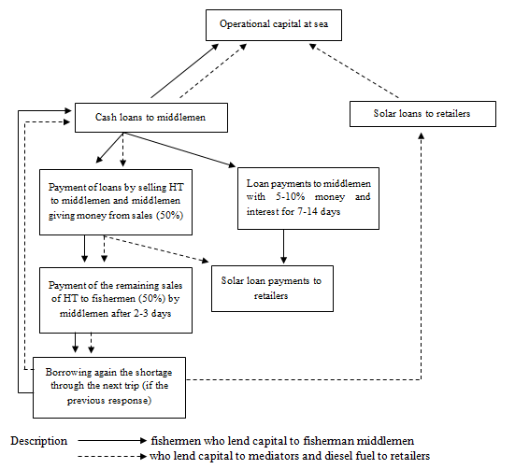

To maintain clarity and consistency, images or tables should not be presented as screenshots. Please recreate them if the data or results are currently in this form.

Picture 1. Picture Title
Source: Picture source, year

Other Conditions :

- Use direct citations from primary sources, avoid formulations like 'according to [xxxx] in [xxxxx]' from the last 10 years using Mendeley app.
- Give an explanation of the abbreviations used in the manuscript.
- Avoid using bullets & numbering in the article. Present the information as a short narrative or table instead.
- Decimals and integers in articles :
- Decimals form : 0.005
- Integers form : 100,000,000

